|  |  |  |  |  |  |
| --- | --- | --- | --- | --- | --- |
| Date | 7-Dec-22 | | | Tester Name | Richard Belanger |
| Environment | Select Environment | | | Login used | Test 2 |
| Operating System | Windows | Version: | Update: | | |
| Software Used | Edge | Version: | Update: | | |
| Select Software | Version: | Update: | | |
| Release version | 22.02.01 | | | | |
| Title | M19.02 Onetime Payments | | | | |
| Test Type | Regression | | | | |
| Test Scenario | Pay out a Member’s payment, verify interest applied Test 2 calculations | | | | |
|  |  | | | | |
| Expected Results | Onetime amount will be paid out with correct interest applied | | | | |
| Pass/Fail | Pass | | | JIRA# | N/A |

Describe your steps with screenshots:

Terminate Member

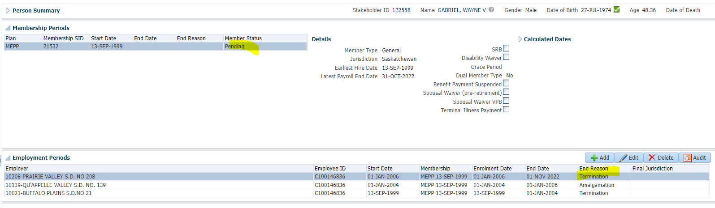

Benefit Calculation Processed

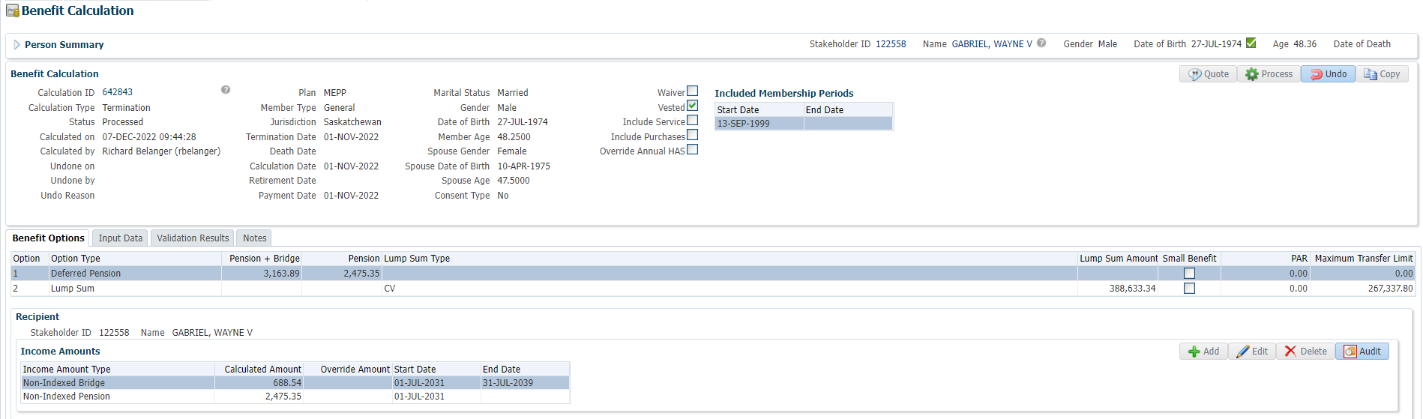

Benefit Selection

Next

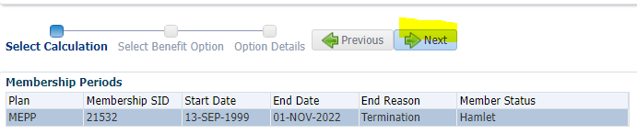

Add Payment Date>Next

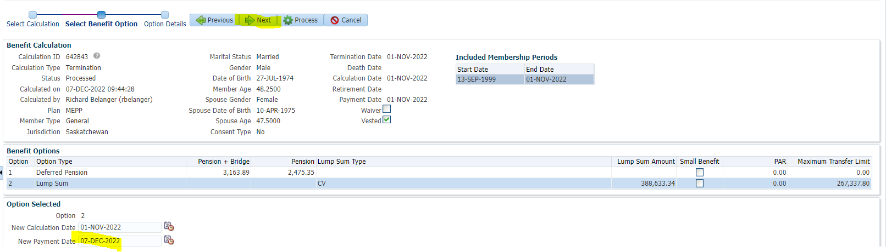

Add Payment Instructions>Process

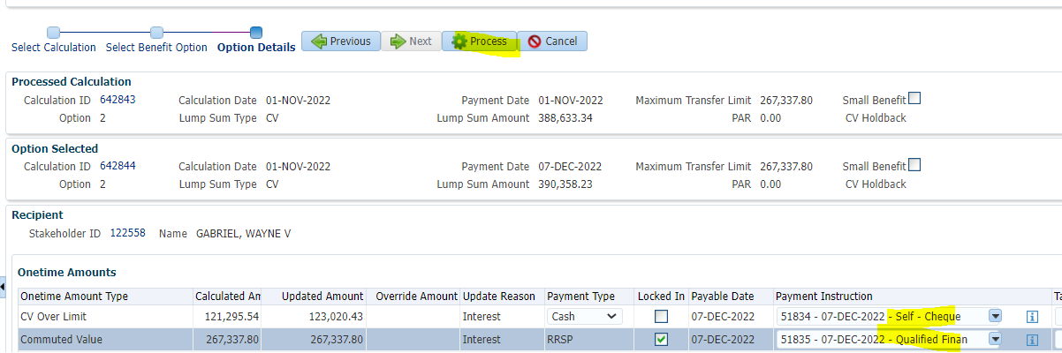

Benefit Recipient>Submit for Approval/Approve>Authorize/Authorized

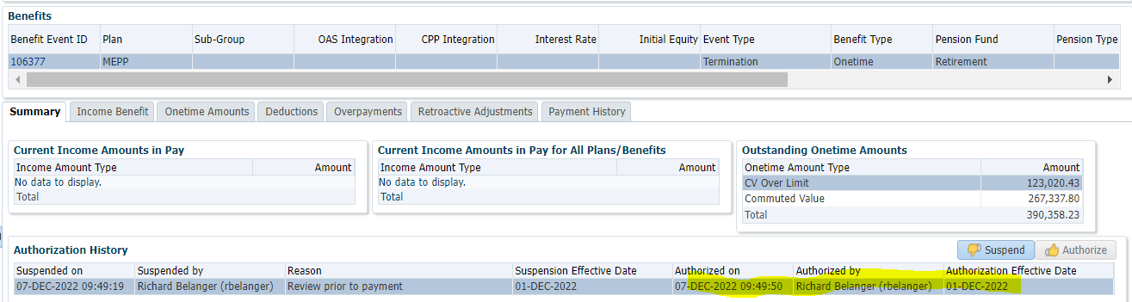

Payment History

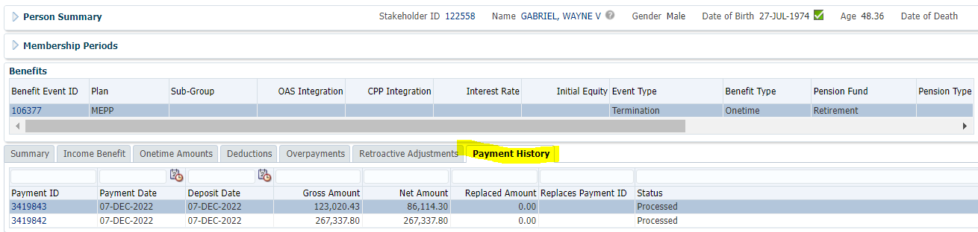

Tax Rates

0.00-4,999.99 = 10%

5,000.00- 14,999.99 = 20%

15,000.00+ = 30%

The 267,337.80 amount is sent to RRSP, no tax taken

The 123,020.43 was a cash payment, subject to 30% tax

123,020.43 * 30% = 36,906.13; 123,020.43 – 86,114.30 = 36,906.13; After 30% tax Net payment = 36,906.13